WOKWI PROJECT

**WOKWI SIMULATOR LINK:**

<https://wokwi.com/projects/347212137885598290>

**NODE-RED DASHBOARD UI LINK**:

[https://node-red-dashboard059.eu-gb.mybluemix.net/ui/#!/0?socketid=Dsj_6KQ1Dt6bk-4LAAAW](https://node-red-dashboard059.eu-gb.mybluemix.net/ui/%23!/0?socketid=Dsj_6KQ1Dt6bk-4LAAAW)

**WEB PAGE LINK:**

<https://node-red-dashboard059.eu-gb.mybluemix.net/fire>

**PREVIEW:**

WOKWI SIMULATOR:

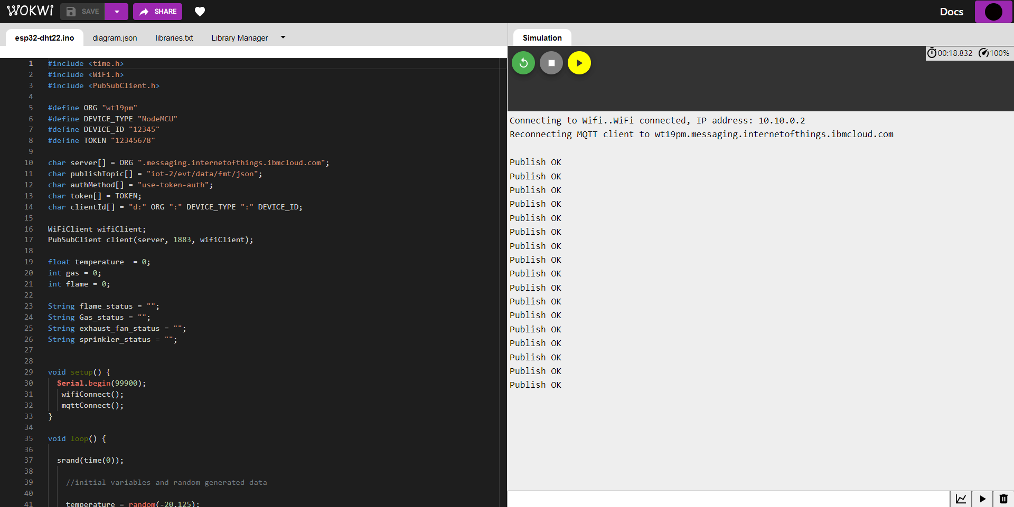

NODE RED:

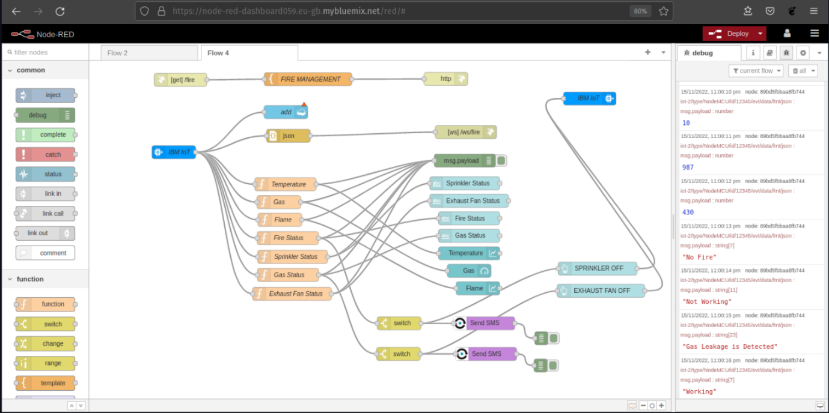

IBM WATSON IOT:

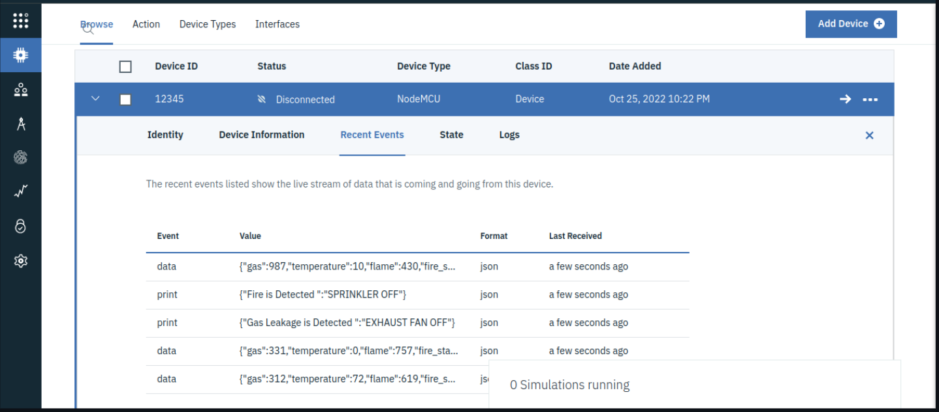

NODE RED (UI):

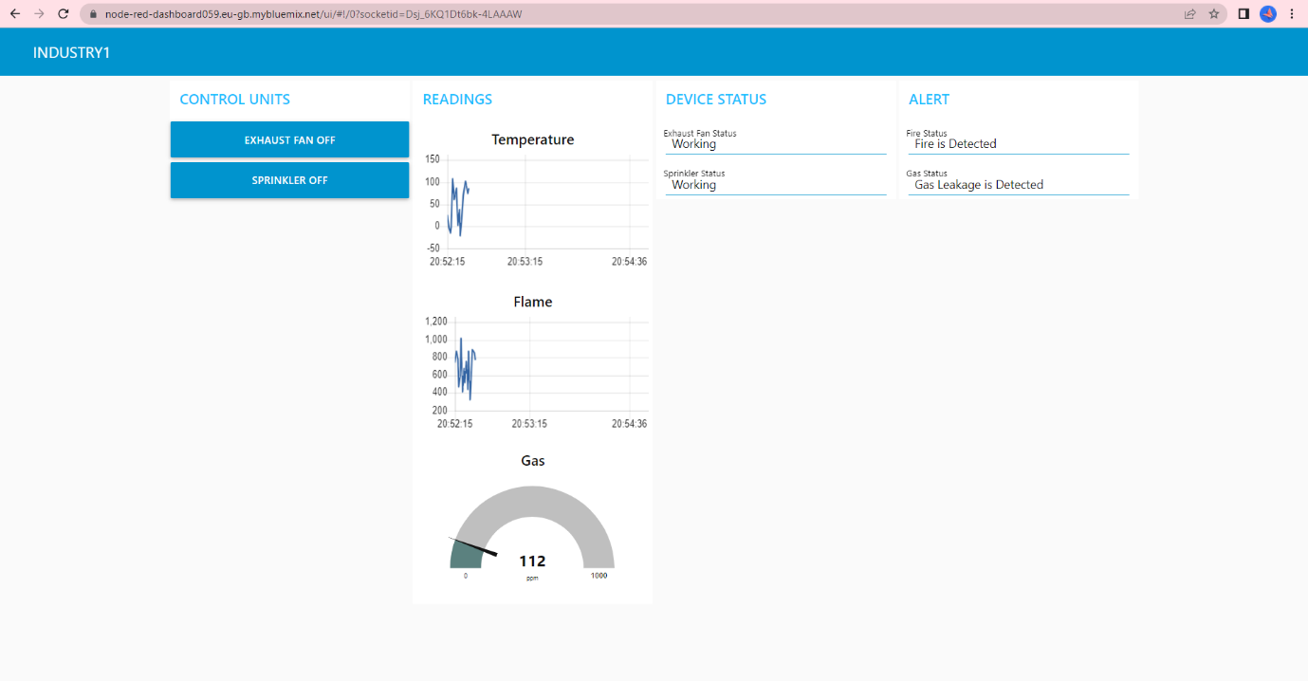

WEB PAGE USING WEB SOCKET:

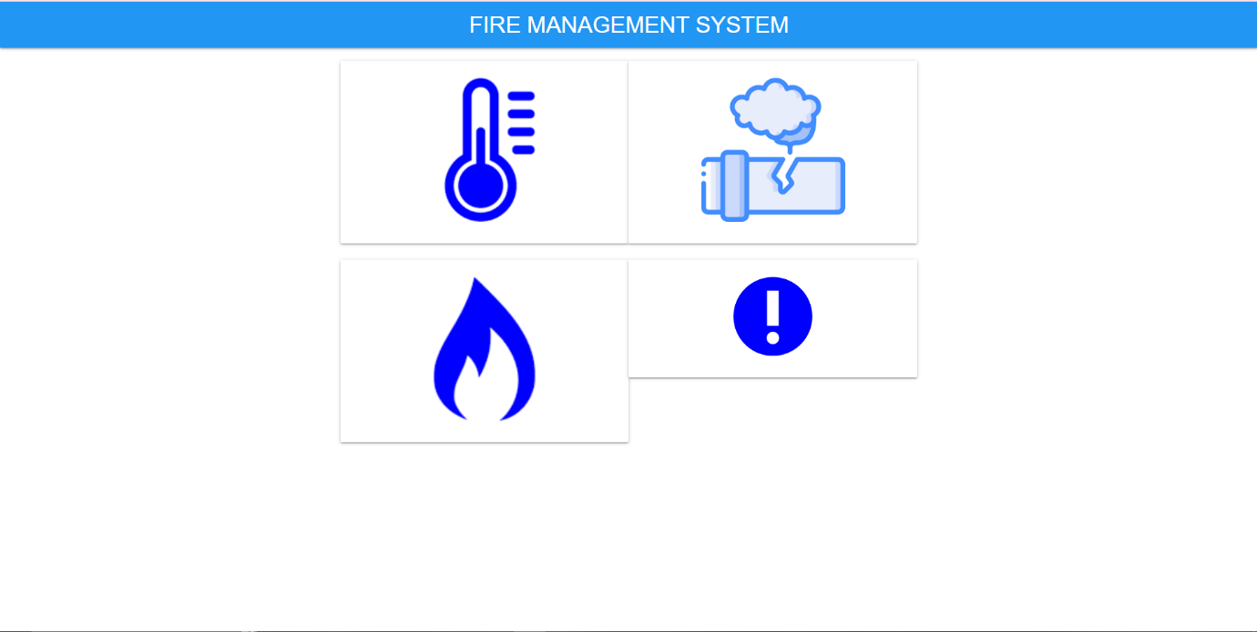

SMS ALERT:

